**May 2015 HL P1**

**Section A**

1. Describe one way that software developers can ensure that the users are aware of any

available updates for their products. [2]

1. Construct a truth table for the following Boolean expression.  
     
    (A or B) and (not C or B*)* [4]
2. Outline one example of the use of a virtual private network (VPN). [3]
3. 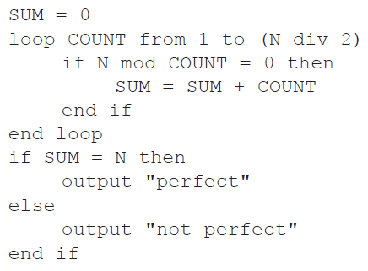Trace the following algorithmic fragment for N = 6. Show all working in a trace table.
4. Use a selection sort to put the following set of numbers into order from highest to lowest.

List the results after each pass.

12 52 16 42 88 86 [3]

1. Describe how a GPS system can identify the position of a person. [3]
2. Describe one way that the operating system of a networked workstation hides the complexity

of the network from the user. [3]

1. 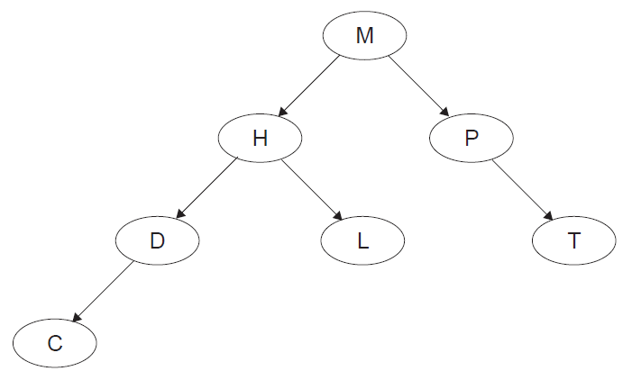Consider the following binary tree.
2. State the order that the nodes will be listed using the postorder tree traversal. [1]
3. The node H is deleted so that the postorder traversal of the **remaining** nodes is

preserved from part (a). Sketch the updated binary tree following this deletion. [2]

1. An insurance company holds a large database of information about its customers, including

the date of their next payment.

Once a month the database is searched to compile the following lists:

* **list 1**: customers whose next payment date will be **within** the next 30 days
* **list 2**: customers whose payment date has passed by **more than** 14 days but

**less than**, or **equal to**, 30 days

* **list 3**: customers whose payment date has passed by **more than** 30 days.

Records of customers who are in list 3 are flagged for deletion.

1. Construct an algorithm to illustrate the monthly process described above. [6]

After the lists have been compiled, the following messages are sent out to customers.

* A reminder is sent to customers in list 1.
* A warning that payments are more than 14 days overdue is sent to customers in list 2.
* cancellation of contract is sent to customers in list 3.

1. Explain how the lists could be used to merge the data from the database with a

word processor to create these messages automatically for sending either by post

or by email. [4]

1. Outline the consequences of data loss to customers and to the company. [2]
2. Describe **one** method that the company could use to prevent data loss. [3]
3. Six lawyers and one secretary work together in the same building and are connected via a

LAN to a central server. Each has their own workstation.

1. Outline the concept of the Open Systems Interconnection (OSI) model in

communication across a network. [3]

1. Outline, with an example, the function of protocols. [3]

The secretary deals with booking appointments for clients. New clients are given the first  
 available appointment with any lawyer and returning clients are given the first available  
 appointment with their usual lawyer.

A new customized computer package is bought to deal with appointment making.

1. Identify the data that needs to be input by the secretary when someone asks for

an appointment. [2]

The data on appointments is held as one page for each day.

1. Describe a suitable data structure to hold the data for one day. [3]
2. Using the data structure you suggested in (d), outline the steps in a procedure to create

an appointment for a client. [5]

1. In a small airport, the details of all flights due to arrive on a particular day are held in a

collection, FLIGHTS. Each object in the collection contains the following information:  
  
ID: unique flight number

PLACE: where the plane is coming from

DUE: the time it is scheduled to arrive

EXPECTED: the time it is expected to arrive (only if it is early or if it is delayed)

ARRIVED: the time of actual arrival.

EXPECTED and ARRIVED are blank at the beginning of the day and the collection is sorted in

order of DUE.

A screen in the airport can display information on 20 planes at a time, which are held in a

linked list.

1. Describe the features of a linked list of 20 planes that have the above information. [3]

All times are stored in the collection as the number of minutes since midnight. However, they  
 are displayed on the screen in 24-hour format (for example, 10:58 is stored in the collection  
 as 658).

1. Construct an algorithm to convert the times held in the collection into hours and

minutes needed for the 24-hour format displayed on the screen. [3]

If a plane arrived more than 30 minutes ago it is removed from the linked list and the next  
 one in the collection is added to the end of the list.

1. With the aid of a diagram, explain how a plane which arrived more than 30 minutes ago

could be removed from the linked list. [4]

1. For the application described above, compare the use of a linked list with the use of a

queue of objects. [5]

1. In a town, a set of traffic lights control access from a small road, where a fire station is

located, to a main road that has heavy traffic. In times of emergency, many vehicles from

the fire station may need to leave the station at the same time. A system is put in place so

that when a fire truck on the small road approaches the main road, the traffic lights switch to

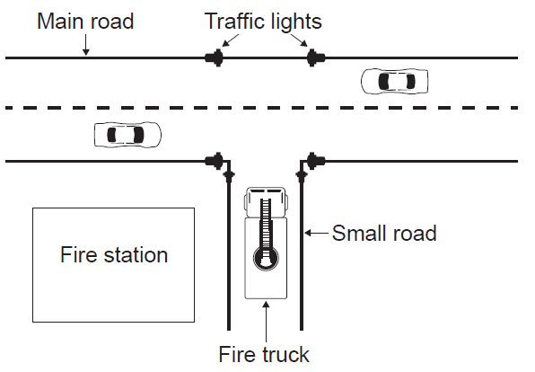green (Go) on the small road and to red (Stop) on the main road.

1. Outline the role of sensors and a microprocessor in controlling the traffic lights in

this way. [4]

1. Suggest how the traffic lights can be changed back to their original state once there are

no more fire trucks coming from the small road. [3]

These traffic lights are controlled by embedded systems at the point of use. It is proposed  
 that they should be controlled from the same central computer as all the other traffic lights in  
 the town.

1. Discuss the advantages and disadvantages of running the town’s traffic light system

on one central computer with multiple inputs and outputs. [5]

A series of cameras are installed at each of the town’s traffic lights. These cameras are  
 connected to the central computer.

1. Discuss the social implications of monitoring traffic in this way. [3]
2. Theo entered a maze (labyrinth) and tries to get to the centre. As soon as he arrived at

the first possibility to turn right or left, he started recording each move on his phone so that

he could find his way back to the start. He entered the moves as the direction he turned

followed by the number of steps taken before the next turn. For example:

R3 , L5 , L10 , R6 , … , L4

which indicates "TURN **right**, STEP **3**", and then "TURN **left**, STEP **5**" etc.

An app on his phone stored the moves in a stack named STK, using 0 for “right” and 1 for “left”.

The above moves were therefore stored as

0 , 3 , 1 , 5 , 1 , 10 , 0 , 6 , … , 1 , 4.

1. Explain why a stack is a suitable structure to hold the data. [2]

Theo was successful in reaching the centre of the maze and now has to get back to the start.

1. Construct an algorithm, using appropriate stack access methods, to output the moves

needed to return from the centre to the first point where Theo started recording his

moves. You can assume that he is **facing** the correct exit when he starts his return

journey. [5]

**Another** app on the phone gives Theo a visual representation of his path through a maze as  
 a map. This app makes use of a procedure MOVE(), which outputs the coordinates of Theo’s  
 path through a maze, in reference to the point S, where he first turned right or left and which  
 has coordinates (0, 0).

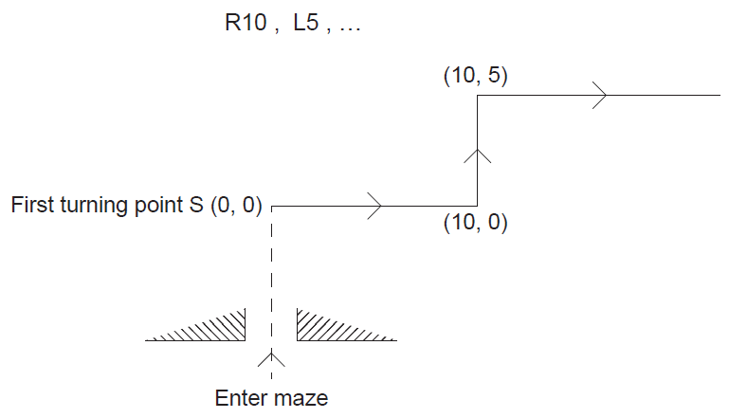 The diagram shows, for a **new maze**, the map from point S given the following moves:

The third move is R8.

1. State the coordinates on the map after this third move. [1]

At each point, the direction in which Theo is facing is given by the variables N and E.  
 Note that before the very first turn is made, N = 1 and E = 0.  
  
  
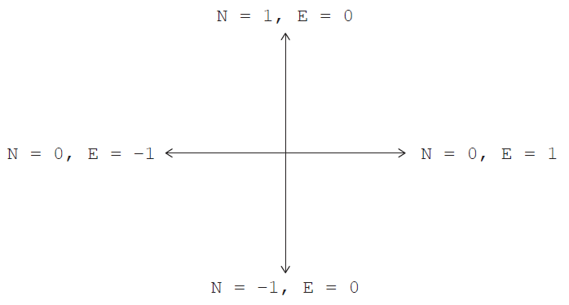

The following table shows **part** of the trace of MOVE() according to the TURN and STEP  
 values: R10 , L5 , R8 , R2 , L3 , R0.

The last move, with a STEP value of 0, indicates that there are no more moves and that the  
 stack is empty.

1. Complete the table by tracing the algorithm on the following page.

